**Water Quality Monitoring**

**Rationale:**

Water scarcity is the lack of sufficient available water resources to meet the demands of water usage within a region.Arduino base water quality monitoring is all about how to monitor the Quality of water, in terms of monitoring the level of water, temperature of the water, the turbidity of the water (how clean the water is) as well as the PH levels of the Water, check the lead content, Nitrite/Nitrate, check for unwanted contaminants and it has an LCD to display the result.

**Statement of the Problem**

It is the difficulty of obtaining sources of fresh water for use during a period of time and may result in further depletion and deterioration of available water resources. Water shortages may be caused by climate change, such as altered weather patterns including droughts or floods, increased pollution, and increased human demand and overuse of water.

* Is there a device that can identify if the water is safe?

**Features:**

* **Check the pH level**
* **Check the temperature**
* **Check the turbidity**
* **Portable**
* **Lead Content**
* **Nitrate/ Nitrite**
* **Check for unwanted contaminants**
* **Display result (LCD**

**Schematic diagram**

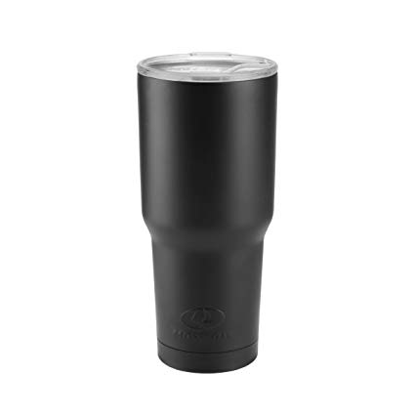

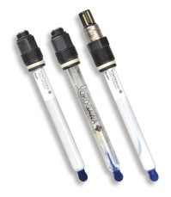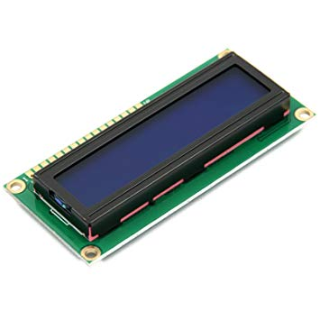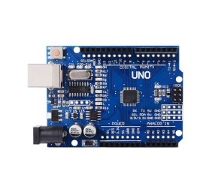

**Block Diagram**

Tumbler

Sensors

LCD

Arduino

**Materials**

* Arduino Mega Board.
* (16 * 2) LCD display.
* The 2 in one Temperature and PH sensor.
* The Turbidity Sensor.
* GSM shield.
* An ultrasonic Sensor.

**System Flow**

LCD Display

Ultrasonic Sensor

A Group of Water

Software

**UNIVERSITY OF CEBU-MAIN CAMPUS**

**COMPUTER ENGINEERING DEPARTMENT**

Osmeña Boulevard Corner Sanciangko Street , Cebu City

DATE : July 3, 2019

TITLE : ARDUINO BASED WATER QUALITY TESTER

Group : Ahrve Kim E. Jabonillo

Jucel Gadiano

Bernard Pañares

Approved

Disapproved

Comments/Suggestions:

________________________________________________________________________________________________________________________________________________________________________________________________________________________________________________________________________________________________________________________________________________________________________________________________________________________________________________________________________________________________________________________________________________________________________

____________________________________________________________________________________________

**Evaluators:**

**_______________________________________**

**(Signature over printed name)**

**_______________________________________**

**(Signature over printed name)**

**_______________________________________**

**(Signature over printed name)**